**2018-2019 JPSS Proving Ground Risk Reduction Quarterly Reporting**

2018-2019 Project Information

**Principal Investigator:** Kimberly Hyde

**Team Members:** Colleen Mouw, Ryan Morse

**Organization:** Northeast Fisheries Science Center; University of Rhode Island

**Project Title**: Optimization of phytoplankton functional type algorithms for VIIRS ocean color data in the Northeast U.S. Continental Shelf Ecosystem

2018-2019 Project Summary

*Elements include project objectives over the entire period of performance. This section should be kept brief to half of one page or less. This may include a bulleted summary. This should not change from quarter to quarter during the performance year.*

This project aims to optimize remote sensing phytoplankton functional type/size class (PFT/PSC) algorithms for the Northeast U.S. Continental Shelf for applications in fisheries management and ecosystem modeling. We will be collecting *in situ* optical and pigment data on six Ecosystem Monitoring cruises operated by the Northeast Fisheries Science Center. All available *in situ* data will then be used to validate the ocean color data (e.g. RRS and IOP products) from VIIRS and other sensors and evaluate several abundance and absorption based PFT/PSC algorithms.

Reporting Period

*Mark table, below, with an “x” corresponding to the quarter submitted*

|  |  |  |  |
| --- | --- | --- | --- |
| *CY2018 Q3*  *Period of Performance: 7/18 to 10/18* | *CY 2019 Q4: 10/1/18 to 12/31/18*  *Due: January 7,2019* | *CY 2019 Q1: 1/1/19 to 3/31/19*  *Due: April 5,2019* | *CY 2019 Q2: 4/1/18 to 16/30/19*  *Due: July 5,2019* |
| Submitted 9/26/2018 |  |  |  |

Quarterly Dashboard



|  |  |  |  |  |
| --- | --- | --- | --- | --- |
|  | Green (Controlled) | Yellow(Caution) | Red(Critical) | Variance Summary *(Provide explanations as needed. More detail may be included in issues and risks sections as needed.)* |
| **Scope** |  |  |  |  |
| **Budget** |  |  |  |  |
| **Schedule** |  |  |  |  |

**Legend**

|  |  |  |  |  |  |
| --- | --- | --- | --- | --- | --- |
|  | *On Target* |  | *Deviation from plan which can be recovered* |  | *JPSS Program Science Attention needed.* |

|  |
| --- |
| Quarterly Accomplishments |

**Accomplishments during this Reporting Period**

1. **Summary of Accomplishments** *(This is a high level summary of quarterly activities. This paragraph should be kept brief to half of one page or less.)*

We participated in our second cruise (31 October – 14 November, 2018) collecting absorption, backscattering, fluorescence, and pigment samples and started post-processing the data. Chlorophyll and colored dissolved organic matter (cdom), HPLC pigment, and nutrient samples from the first cruise (22-31 August) are currently being analyzed at the University of Rhode Island, Horn Point Laboratory, and University of Maine respectively. We have developed a project database to organize all project related data and are continuing to compile optical, pigment, and phytoplankton imagery data in the region from other sources. Satellite datasets from multiple sensor are up-to-date and we are starting to compare the data products from multiple sensors.

1. **Milestones Progress** *(Provide details of the progress of each activity or milestone for this quarter as relevant. Quarterly Reports should reflect only current quarter.)*

* Field Sampling 2 (31 October – 14 November, 2018) – 100% Complete
* Laboratory Analyses 1 – 50% Complete (On Time)
* Data Compilation – 60% Complete (On Time)
* Satellite Data Processing (Continuous) – 90% Complete (On Time)

**Plans for the next Reporting Period:**

* Continue laboratory analyses
* Data Compilation (phytoplankton imagery data)
* Satellite Processing and analysis (satellite-ship data match-ups)
* Conduct review of several published PFT/PSC algorithms

**Additional Information** *(This include the following, as relevant. If particular elements are not relevant to quarterly activities, write N/A/)*

1. **User engagement:** *(In addition to PGRR meetings, this includes collaboration and support for other stakeholders such as upper level management or other agencies such as FEMA. This may include a specific event like a large fire or hurricane or a field experiment, for example.)*

N/A

1. **Conference/workshop participation:** *(Conference Name, dates, materials presented)*

Kyle Turner (supported graduate student), poster, Investigating the Influence of Cell Size on Spectral Phytoplankton Absorption at the GSO Dock, Biological Oceanography student presentation, December, 6, 2018.

1. **Project publicity:** *(news journals/articles etc.)*

NEFSC Press Release: <https://www.nefsc.noaa.gov/press_release/pr2018/features/plankton-satellites/>

URI Press Release: <https://today.uri.edu/news/uri-oceanographers-among-scientists-looking-to-the-ocean-to-improve-satellite-data/>



Quarterly Pictures and Graphics

Photographs taken by Kyle Turner, University of Rhode Island, during the November 2018 Ecosystem Monitoring cruise on the University of Delaware’s RV Hugh R. Sharp.

1. CTD Rosette set-up
2. Flow-through system that includes a thermosalinograph, an AC-S, flouorometers for chlorophyll-a, colored dissolved organic matter and phycoerythin, and 3 BB-3’s (equivalent to a BB-9).
3. Sample output from the Imaging FlowCytobot (IFCB, Woods Hole Oceanographic Instuitute)

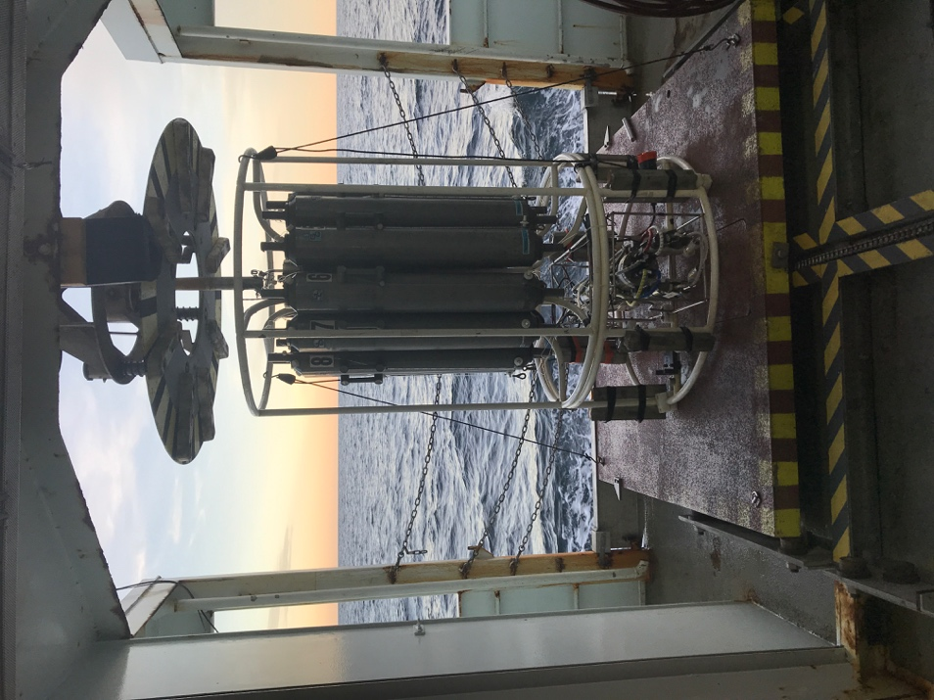

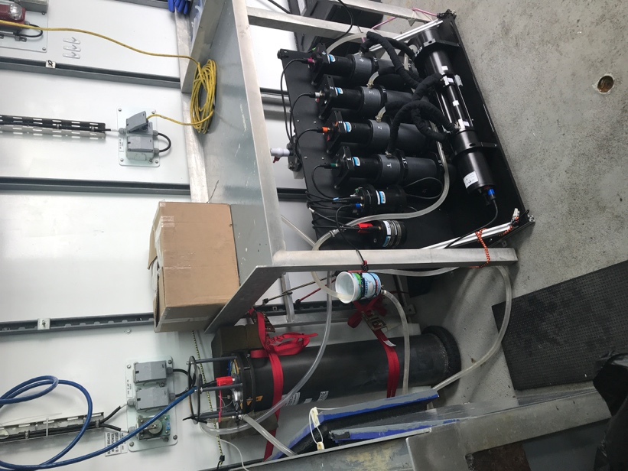

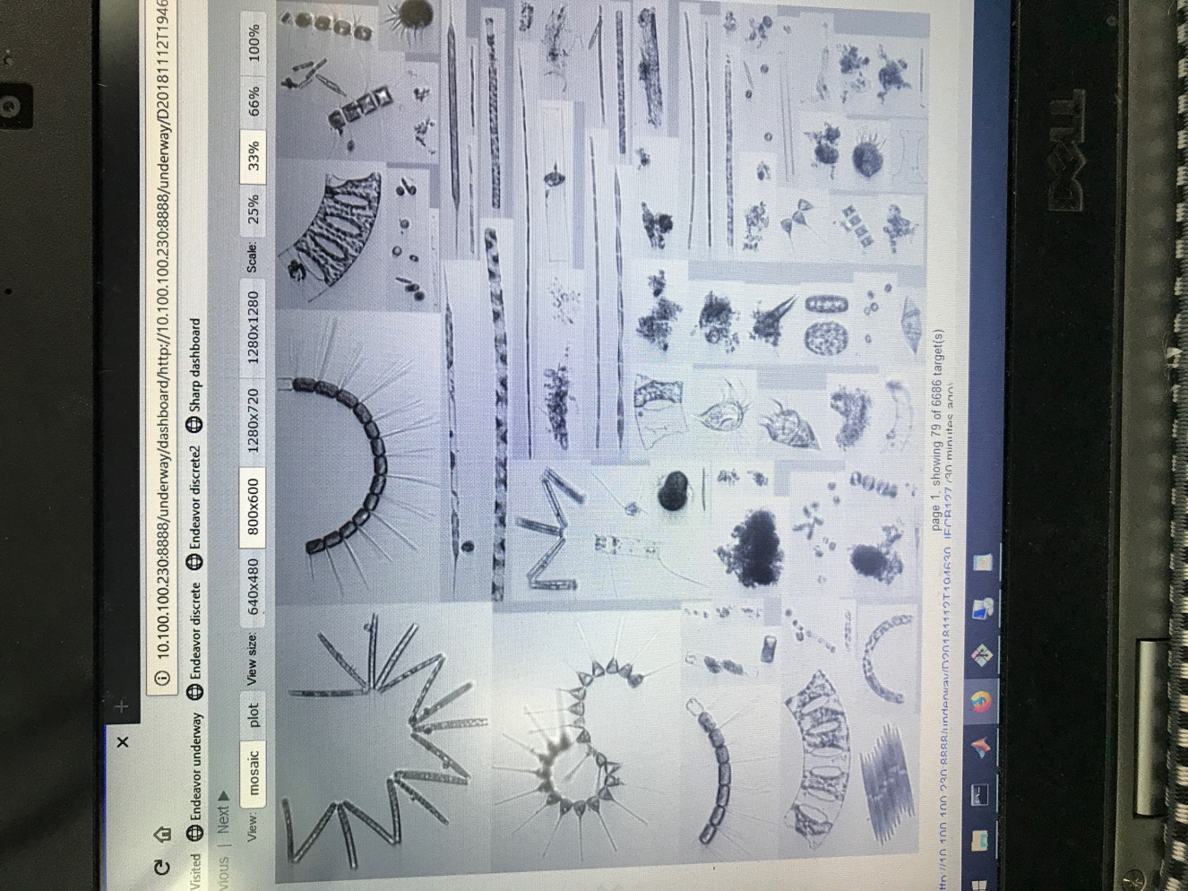

2018-2019 Annual Milestones with Quarterly Status Updates

*2018-2019 plan, schedule and milestones should build upon project proposals and allocated budget. This plan serves as a project management tool allowing PI’s to track and meet goals. Tasks are activities that need to be accomplished within a defined period of time. Tasks are broken down into milestones with defined start and end dates. The level of granularity is defined by individual PI. This table should be used for future quarterly reports.*

|  |  |  |  |
| --- | --- | --- | --- |
| **Milestone** | **Planned Completion Date**  *(should be part of annual plan and should not change from quarter to quarter)* | **Actual Completion** | **Status** *(not started, on track, delayed, completed …)* |
| Task 1: Field Sampling & Sample Analyses | | | |
| Field Sampling 1 | 8/31/2018 | 8/31/2018 | Completed |
| Field Data Analysis 1 | February 2019 |  | On Track |
| Field Sampling 2 | 11/14/2018 | 11/14/2018 | Completed |
| Field Data Analysis 2 | May 2019 |  | On Track |
| Field Sampling 3 | June 2019 |  | Not Started |
| Field Data Analysis 3 | December 2019 |  | Not Started |
| Field Sampling 4 | August 2019 |  | Not Started |
| Field Data Analysis 4 | February 2020 |  | Not Started |
| Field Sampling 5 | November 2019 |  | Not Started |
| Field Data Analysis 5 | May 2020 |  | Not Started |
| Field Sampling 6 | February 2020 |  | Not Started |
| Field Data Analysis 6 | August 2020 |  | Not Started |
|  |  |  |  |
| Task 2: Data Compilation & Analysis | | | |
| Data compilation | May 2020 |  | On Track |
| Satellite data processing | Continuous |  | On Track |
| Preliminary data analysis/validation | October 2020 |  | Not Started |
|  |  |  |  |
| Task 3: Algorithm optimization | | | |
| Algorithm validation & optimization | May 2021 |  | Not Started |
| Time series analysis | May 2021 |  | Not Started |
| Modeling efforts | December 2020 |  | Not Started |
| Publication writing | June 2021 |  | Not Started |

*Add rows as needed for all annual tasks and milestones. New milestones which may arise should be added at the end of the table as needed.*

|  |
| --- |
| Issues and Risks |

##### *This section should include no more than five or issues. Please separate risks from issues. Risks are the bad things that might happen. Dependencies on other projects and resources are considered risks. Issues have already occurred. High impact variances from Quarterly Dashboard can be addressed here as needed.*

##### Risk or Issue: *(State risk or issue and impact.)*

##### Issue – A NOAA vessel was not available for the Fall 2018 Ecosystem Monitoring cruise. NEFSC was able to contract the University of Delaware’s RV Hugh R. Sharp for the cruise, but due to weather and the ship’s availability, the cruise track was shortened and samples were only collected in the Mid-Atlantic and Southern New England shelves.

##### Risk – Changes in the availability of the NOAA ships and weather could cancel or reduce the sampling plan of the Ecosystem Monitoring cruises.

1. Risk – If staff from NESDIS are unable to participate in future cruises then the in-water radiometry and particle absorption samples may not be collected.

##### Mitigation Plan or Course Correction: *(This includes options and actions to reduce risks/threats to project objectives. For issues, this includes plans to address impacts.)*

##### Mitigation Plan – As with any field sampling program, the data collection is dependent on the ship availability and crew safety. We collected as many samples as possible within the available time window. Part of this project also involves using data from outside sources to supplement our field sampling.

##### Mitigation Plan – If an Ecosystem Monitoring cruise is canceled, we can try to piggy-back on another NOAA/NEFSC cruise.

1. Mitigation Plan – Dr. Mouw has the equipment to collect in-water radiometry and analyze particle absorption samples, however the additional staff time, equipment maintenance, and supplies were not budgeted for in this project.

##### Status: *(If an issue or risk is closed, then it should not be reported in subsequent quarters.)*

|  |  |  |  |  |
| --- | --- | --- | --- | --- |
| **Issue/Risk** | **No Change/Open** | **Increasing** | **Decreasing** | **Closed** |
| **1** |  |  |  |  |
| **2** |  |  |  |  |
| **3** |  |  |  |  |
| **4** |  |  |  |  |
| **5** |  |  |  |  |

##### Comments: *(as needed)*